Clinical Features and Laboratory Analysis of Acute Lymphoblastic Leukemia: The Most Common Type of Leukemia Diagnosed at a Tertiary Care Hospital

NIGHAT NASIM, KALIMUDDIN MALIK
Department of Pathology, Post Graduate Medial Institute, Lahore
Correspondence to: Dr. Nighat Nasim, Assistant Professor Pathology, PGMI. E-mail: nighat.pgmi@hotmail.com

ABSTRACT
Objective: The objective of this study was to analyze the most common type of leukemia in the indoor and outdoor patients at Lahore General Hospital/Post Graduate Medical Institute (LGH/PGMI) Lahore.
Study Design: A cross-sectional prospective observational study.
Setting: Bone Marrow Clinic at LGH and PGMI, Lahore.
Duration: A four year study carried out from November, 2008 till November, 2012.
Patients and Methods: All cases of Acute Lymphoblastic Leukemia (ALL) diagnosed on bone marrow examination, belonging to all age groups and both sexes were included. The already diagnosed leukemia patients and patients on chemo or radiotherapy were excluded. A detailed relevant history was obtained; general and physical examination, complete blood counts and bone marrow examination were performed.
Results: Out of 75 cases diagnosed to have leukemia, acute lymphoblastic leukemia (ALL) was the most common type of leukemia (44%). AML (34.7%) was the second most common type, CML (14.7%) was the third and CLL (4%) was the fourth in order of frequency. There was a single case each of HCL (1.3%) and CMML (1.3%) (Table 1).
In the 33 diagnosed patients of ALL, 60% were males and 40% females. ALL cases had a higher rate of frequency in children (55%) as compared to adults (45%). ALL-L₂ was the most common subtype of ALL. The most common presenting symptoms were pallor (94%), fever (84%) and weakness (55%). Splenomegaly (79%), hepatomegaly (67%), lymphadenopathy (58%) anemia (94%) thrombocytopenia (72%) and leukocytosis (45%) were important clinical signs. One patient had the congenital anomaly Down’s syndrome.
Conclusion: Acute lymphoblastic leukemia ALL is the most common hematological malignancy. It is more frequent in children and male patients. ALL-L₂ is the most common subtype noted.

Key words: Leukemia, ALL.

INTRODUCTION
The leukemias are a group of disorders characterized by the accumulation of malignant cells in the bone marrow and blood. The abnormal cells cause symptoms because of i) bone marrow failure (e.g. anemia, neutropenia, thrombocytopenia) and ii) infiltration of organs (e.g. liver, spleen, lymph nodes meninges, brain, skin or testes).¹
Acute leukemias are highly malignant and are responsible for a large number of cancer-related deaths. Although the survival rates have improved remarkably in young age group, the prognosis in older age patients is still poor.²
Hematological malignancies represent approximately 7% of all malignant diseases. The first case of leukemia was reported by John Hugles Bennet in 1845 in an adult patient.³ Leukemia in a child was first reported by Dr. Henry Fuller in 1846.⁴ The disease remained universally fatal till the discovery of effective chemotherapy.⁵
The etiology of leukemia like other tumors remains unclear. Certain etiological features like viruses, radiation, toxic chemicals and hereditary and congenital factors do play a role.⁶Leukemia clinically presents with fever, pallor, bleeding, bruises, bone pain and fatigue.The common clinical signs of leukemia include anemia, petechia, bruises, thrombocytopenia, hyperleucocytosis, lymphadenopathy, splenomegaly, hepatomegalyand bone tenderness. The duration of illness before diagnosis is variable. It may be from 6 weeks to 6 months. The disease may however have a very fast course.⁷
The main classification of leukemia is into 4 types: acute and chronic leukemias which are further subdivided into myeloid and lymphoid.
In view of the multidimensional picture of leukemia, this 4 year study was carried out in the department of Pathology, PGMI/LGH Lahore to find out the frequency, clinical profile and laboratory analysis of acute lymphoblastic leukemia which turned out to be the most common type of leukemia out of its 4 main types.

PATIENTS AND METHODS
This study was carried out at Pathology Department of Post Graduate Medical Institute Lahore for a period of 4 years from November, 2008 – November, 2012. Out of a total of 400 patients, 75 (18.75%) patients were diagnosed to have leukemia. All the indoor and outdoor patients at Lahore General Hospital from all the departments were included. All cases of leukemia diagnosed on bone marrow examination belonging to all age groups and both sexes were included in the study.A detailed history including age, sex, occupation along withclinical and laboratory findings was obtained. Previously diagnosed treated or relapsed patients were excluded. Clinical examination included signs of pallor, jaundice, splenomegaly, hepatomegaly, lymphadenopathy and petechiaor bruises. The laboratory analysis consisted of hematological parameters performed on an electronic counter. They were hemoglobin level, red cell indices, total and differential white cell count and platelet count. The peripheral blood smears were examined microscopically. Bone marrow examination includes aspiration and trephine biopsy of all cases except children under one year age group in whom bone marrow aspiration from tibia was obtained.
The peripheral blood smears and bone marrow aspirations were stained with Geinsa stain. Trephine biopsies were stained with Hematoxylin and Eosin. The special stain, Sudan Black B was the main cytochemical stain for classifying acute leukemia into acute myeloid (blast cells positive with stain) and acute lymphoblastic leukemia (blast cells negative with SBB). The diagnosis of leukemia was established on the basis of morphology and cytochemistry of blood and bone marrow smears. The criterion for diagnosis was FAB classification.

RESULTS
Out of the total 75 patients diagnosed to have leukemia, the etiological breakup revealed ALL (44%) as the most common type, followed in order by AML (34.7%), CML (14.7%), CLL (4.0%), CMML (1.3%) and HCL (1.3%) (Table 1).The frequency of subtypes of ALL showed that ALL-L₂ (85%) was the most frequent followed by ALL-L₁ (15%) and none in the subtype ALL-L₃ (Table 2).
In 33 cases of ALL, 20 patients (60%) were males and 13 (40%) were females. The male to female ratio was 1.5:1 (Figure 1). ALL cases had a higher rate of frequency in children (<15 years) (18 cases: 55%) than in adults (>15 years) (15 cases: 45%) (1.2:1) (Figure 2).

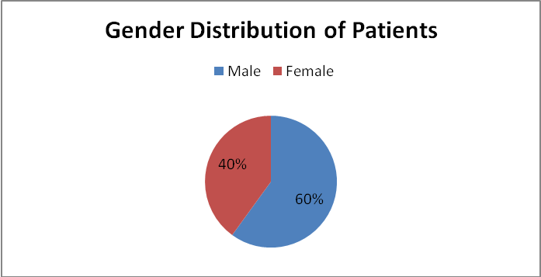

Figure 1: Gender Distribution of Patients

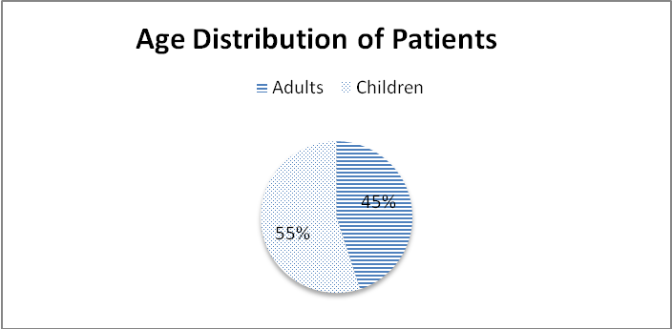

Figure 2: Age Distribution of Patients

Table 1: Different Types of Leukemia

Type of Leukemia | No. of Patients | Percentage (%)
ALL | 33 | 44
AML | 26 | 34.7
CML | 11 | 14.7
CLL | 03 | 4.0
CMML | 01 | 1.3
HCL | 01 | 1.3
Total | 75 | 100

Table 2: Frequency of Subtypes of All

Subtype of ALL | No. of Patients (%)
ALL-L₁ | 5 (15)
ALL-L₂ | 28 (85)
ALL-L₃ | -
Total | 33 (100)

Table 3: Clinical Symptoms of All

Symptom | ALL Cases (n=33) | Percentage (%)
Pallor | 31 | 94
Fever | 28 | 84
Weakness | 18 | 55
Bleeding | 16 | 48
Shortness of breath | 14 | 42
Fatigue | 11 | 33
Productive cough | 10 | 30
Weight loss | 10 | 30

Table 4: Common Clinical Signs of All

Signs | No. of Patients | Percentage (%)
Splenomegaly | 26 | 79
Hepatomegaly | 22 | 67
Lymphadenopathy | 19 | 58
Petechiae | 08 | 24
Jaundice | 06 | 18
Gum hypertrophy | 03 | 9
Intraorbital swelling | 02 | 6
Parotid swelling | 01 | 3

Table 5: Peripheral Blood Findings in All

Parameter | No. of Patients | Percentage
Anemia | 31 | 94
Thrombocytopenia | 24 | 72
Leukocytosis | 15 | 45
Leucopenia | 6 | 18

The most common presenting symptoms included pallor (94%), fever (84%), weakness (55%) and bleeding (48%) from different sites. The lesser common symptoms were shortness of breath (SOB) (42%), fatigue (33%), productive cough (30%) and weight loss (30%)(Table 3).
The important physical signs included splenomegaly (79%), petechiae (24%), hepatomegaly (67%), lymphadenopathy (58%), jaundice (18%), gum hypertrophy (9%), intraorbital tumor (6%) and bilateral parietal swelling (3%) (Table 4). Important peripheral blood finding were anemia (79%), thrombocytopenia (72%), leukocytosis (45%) and leucopenia (18%) (Table 5).

DISCUSSION
The present study revealed that ALL (44%) was the most prevalent leukemia with a male preponderance (1.5:1) an observation similar to Ries et al 1991.⁸
The patients in the children age group were affected more than the adults (1.2:1). The relative frequency of leukemia is similar throughout the world. Certain geneticdisorders like Down’s syndrome, Bloom’s syndrome and Fanconi’s anemia have more chances to develop ALL⁹.In the present study, one patient had Down’s syndrome, consistent with the study by Nuzhat et al 2009¹⁰ and Fauzia et al 2008¹¹.
The patients were brought in with wide spectrum of symptoms and duration. The most common presenting symptoms were pallor (94%), fever (84%), generalized weakness (55%) and bleeding (48%) from different sides. SOB (42%), fatigue (33%), productive cough (30%) and weight loss (30%) were the other less common symptoms. The physical examination revealed splenomegaly (79%), hepatomegaly (67%), lymphadenopathy (58%) and petechiae (24%). These are the very common features of leukemia and findings are consistent with other studies (Liaqat et al 1999¹², Nuzhat et al 2009 and Fauzia et al 2008).The less common signs were gum hypertrophy (9%), intraorbital swelling (6%) and parotid swelling (3%) are attributable to leukemia infiltrating other organs.The hematological parameters were: anemia (94%), thromobocytopenia (72%), leucocytosis (45%) and neutropenia (18%).
The presence of fever with visceromegalyand lymphadenopathy raises a strong suspicion of leukemia, especially when seen in association with anemia, thrombocytopenia and neutropenia. Diamond CA¹³ has shown leukopenia and bone marrow hypoplasia in 51% of his cases. At times, the development of leukemia is preceded by a phase of bone marrow hypoplasia.
Bone marrow examination remains the gold standard to identify and confirm the diagnosis of leukemia. Blast cells are the pathognomonic cells of acute leukemia. The WHO classification defines a case as acute leukemia with 20% or more blast cells. In the present study, the range of blast cells were from 70% - 90% consistent with the study by George SL¹⁴ (blasts 65% - 90%).

CONCLUSION
ALL is the most common hematological malignancy. It is more frequent in children and male patients and ALL-L₂is the most common subtype noted.

REFERENCES
- A.V Hoffbrand. P.A.H.Moss. Essential Hematology 6thEd. Wiley-Blackwell:2008.
- Jemal A, Siegel R, Ward E. Cancer statistics, 2006.CA cancer J Clin.2006; 56: 106-130.
- Benett JH. Case of hypertrophy of sleep and liver in which death took place from suppuration of blood.Edin Med Sur J 1845; 64: 413-23.
- Fuller HW.Particulars of a case in which enormous enlargement of the spleen and liver together with dilation of all the blood vessels of the boy were found co-incident with a peculiarly altered condition of the blood. Lancet 1846; 2: 43-4.
- Pinkel D. Lessons from 20 years of curative therapy for childhood acute Leukemia.Br J Cancer 1992; 4: 148-53.
- Whittaker JA. Fudge M. Etiology of Acute Leukemia. Whittaker JA; Delamore IW.Leukemia.Blackwell Scientific Publications 1987; 122.
- Willoughby MLN.Leukemia and related disorders.Pediatric Hematology (1977) (ed. by) Churchill Living stone, Edinburgh.London and New York.1977: 374.
- Ries, L.A., Kosary, C.L. and Hankey, B.F. (Eds.), 1991. SEER Cancer Statistics Review, 1973-1996. National Cancer Institute. Bethesda, Md.
- Margolin JF, Poplack Dg. Acute Lymphoblastic Leukemia. In Pizzo PA, Poplack DG, editors.Principles and practices of pediatric oncology.Philadelphia: Lippincott Raven 1997; p. 409-63.
- NuzhatYasmeen. Shamvil Ashraf. Childhood Acute Lymphoblastic Leukemia; Epidemiology and ClinicopathologicalFeatures.JPMA 59; 150: 2009.
- Fauzia Aziz. Irfan Zia Qureshi. Clinical and Cytogenetic Analyses in Pakistani Leukemia Patients. Paskitan J. Zool, vol. 40 (3), pp. 147-157, 2008.
- Liaqat Ali. Safia Sharif. Alia Zaidi. Incidence and Clinical Profile of Leukemia in Children.JPMA- 1999: vol. 13 No.2.
- Diamond CA et al. Childhood Acute Lymphoblastic Leukemia.Paeds. Annual 1988, 17-20.
- George SL. Aur RJA et al. A reappraisal of the results of stopping therapy in childhood leukemia. N Engl J med 1979, 269-300.

