Functional Out Come of Surgical Treatment of Old Montegia Fracture Dislocation in Children

FAISAL MUSHTAQ, YAWAR ANIS, MUHAMMAD SALEEM, RAO SAEED
Department of Orthopaedic, Fatima Jinnah Medical College / Sir Ganga Ram Hospital Lahore

ABSTRACT
Chronic (neglected) radiocapitellar joint dislocation is one of the feared complications of Monteggia fractures especially when associated with subtle fracture of the ulna bone. Many treatment strategies have been described to manage chronic Monteggia fracture and the need for annular ligament reconstruction is not always clear. The purpose of this study is to highlight the operative management of missed Monteggia fracture dislocation and to achieve excellent results rather to delay the treatment and later on facing more complication in the form of deformity and loss of movements. Ten patients with an average of 3 months old fracture dislocation were included in the study. Results were evaluated according to the Kims Criteria. Open reduction and internal fixation with plate and screws of the forearm bones and relocation of radial head was done. Radial head was kept located at its position with the help of K wire for 6 weeks

Key Words: Montegia fracture dislocation, K Wire.

INTRODUCTION AND HISTORICAL REVIEW
Monteggia in 1814 first described the injury consisting of a fracture of the proximal third of the ulna and a anterior dislocation proximal epiphysis of the radius. Bado subsequently redefined the Monteggia lesion as a group of traumatic lesions having in common a dislocation of the radiohumeral joint, associated with a fracture of the ulna at various levels. Monteggia fractures account for 0.4% of all forearm fractures. The peak incidence occurs between the ages of 4 and 1 0 years. Treatment of all the missed Montegia fracture dislocation should be operative if we want to achieve good functional results

Bado's Classification
Type I: Anterior dislocation of the radial head and fracture of the u[nar diaphysis at any level with anterior angulation. Most common fracture pattern.
Type II: Posterior dislocation of the radial head and fracture of the ulnar diaphysis with posterior angulation. Rare in children.
Type III: Lateral dislocation of the radial head with fracture of the ulnar metaphysis. More common in children than adults.
Type IV: Anterior dislocation of the radial head with fracture of the proximal third of the radius and fracture of the ulna at the same level.
All our cases were type 1 Montegia fracturesdislocation except one patient who was having type 4 injury.

PATIENTS AND METHOD
In a prospective study 10 patients with mean age of 6.Syears were presented during the period from June 2010 to April 2012. All patients were suffering from fracture of ulna with anterior dislocation of radial head that was 3-4 months old. They seeked treatment from local bone setters during the prehospital period.
All children underwent open reduction of the radiocapitellar joint and required angulation- distraction osteotomy of ulna without ligament reconstruction.The fracture of radius and ulna were fixed with3.5mm small fragment dynamic compression plate. Radial head was stabilized with a 1.5 mm stainless steel wire passed from it to the capitellum after open reduction of radiocapitellar joint. This wire was removed after 3 weeks. All patients were classified as Bado type lexcept one patient that was Bado type 1 V who presented with fracture of both radius and ulna with anterior dislocation of radial head. We used the Kim's criteria to score our results.

RESULT
The mean follow-up period was 6 months (S-7 months). At the last follow-up, all patients were rated accordin?m to the functional elbow score devised by Kim 8 .
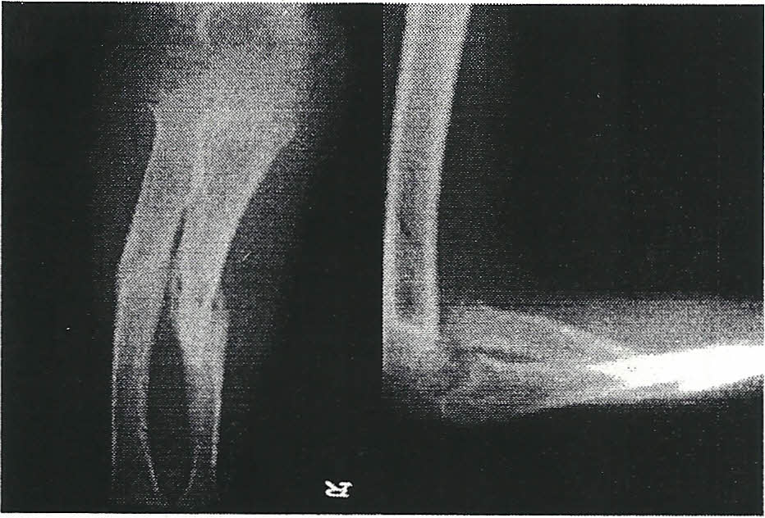

Figure 1: AP and Lateral Radiograph showinng fracture both Radius and Ulna with dislocation of Radial head (Montegia type 1 V)

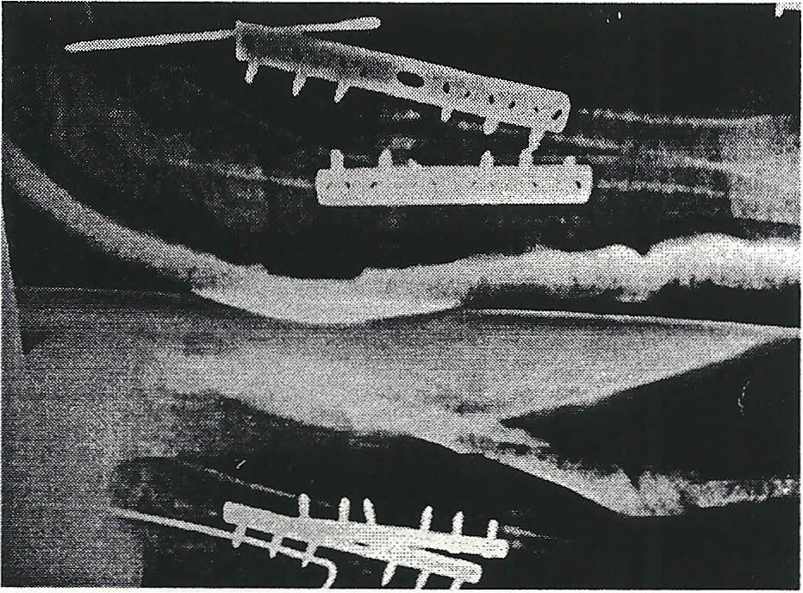

Figure 2: Postop Radiograph Showing fixation of Radius and Ulna with Compression Plate and Pinning of Radial Head

Table 3: Details of pre and postoperative elbow function

No | Flexion Arc in Degrees |  |  | Change | Pronation |  | ISupination |  | in | Kim Score
 |  |  |  | in | Degrees
 | Normal | Affected Side |  | Range | Preop | postop |  | Change | in
 | Side | Preop Post op |  |  |  |  |  | Range
1 | 140 | 135 | 125 | -5 | 160 | 150 |  | -10 |  | Good
2 | 135 | 130 | 130 | Nil | 170 | 170 |  | Nil |  | Excellent
3 | 140 | 125 | 135 | 10 | 150 | 160 |  | 10 |  | Excellent
4 | 135 | 120 | 135 | 15 | 140 | 160 |  | 20 |  | Excellent
5 | 145 | 140 | 140 | Nil | 180 | 160 |  | -20 |  | Good
6 | 135 | 135 | 125 | -5 | 170 | 170 |  | Nil |  | Excellent
7 | 135 | 130 | 115 | -15 | 160 | 150 |  | -10 |  | Good
8 | 145 | 140 | 145 | 5 | 150 | 160 |  | 10 |  | Excellent
9 | 140 | 140 | 125 | -15 | 100 | 140 |  | 40 |  | Excellent
10 | 130 | 120 | 140 | 20 | 135 | 150 |  | 15 |  | Excellent

Negative values indicate loss of motion Kim's Criteria

Deformity Score | No Concern | Minor Concern | Major Concern
 | 25 | 15 | 0
Pain Score | No Pain | Mild- Intermittent | Activity Lirnitinq
 | 25 | 15 | 0
ROM Score | >250 | 200-250 | <200
 | 25 | 15
Function ADL | No Problem | With Difficulty | Unable
 | 25 | 15

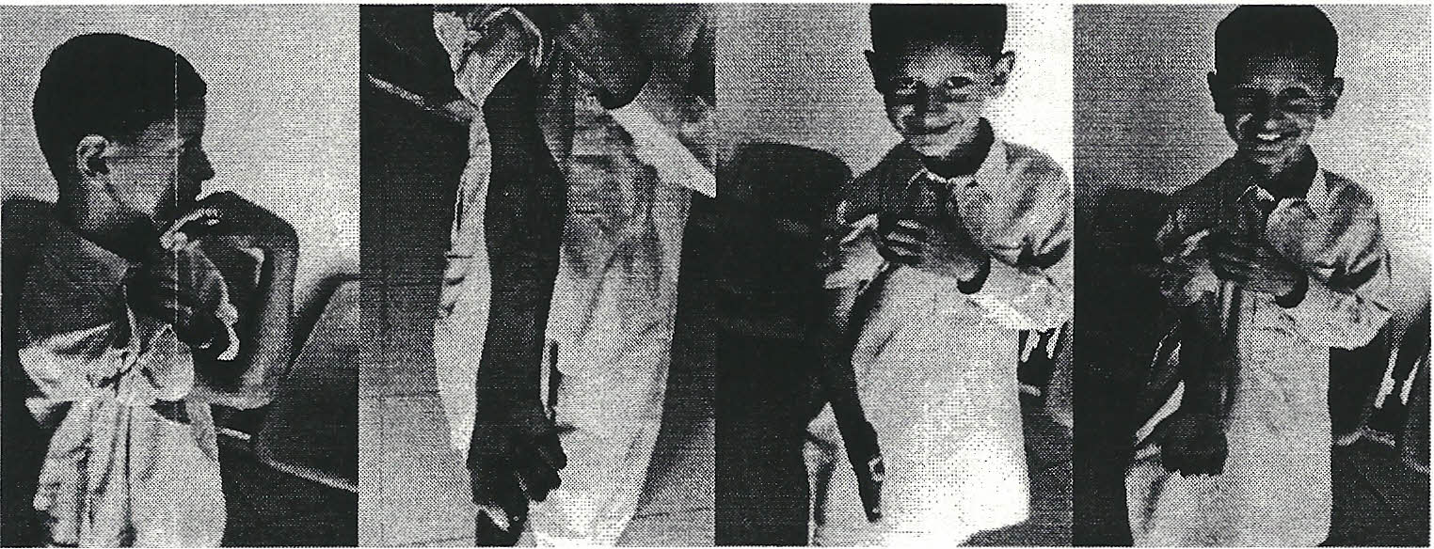

Figure 3: Followup 8 weeks after operation showing good movements of forearm and elbow

The mean age in both the groups, was 6.5 years and the mean duration of "missed dislocation" was 3.5 months. The mean healing time for the ulna ,. osteotomy for all children was eight weeks (6 - 14 "weeks). The elbow range of motion was recorded '; for all patients.AII ulna osteotomies healed ; uneventfully. The mean loss of pronation was 15 , degree. Elbow flexion improved from the ~ preoperative range and no child complained of pain, deformity and restriction of activity. The elbow score was excellent in 7 cases, and good in 3 cases. Supination and pronation improved in 5 cases and there was no change in 3 patients It degreased in 3 cases but remained in acceptable limits.

DISCUSSION
In a patient with a severe injury to the forearm, the dislocated radial head is usually easily detected in. the presence of the displaced ulnar fracture, but in less severe injury with minimal angulation of the ulnar fracture, the dislocation may be missed. In the literature, as many as one third of these diagnoses were missed initially 1,2. Reported factors leading to misdiagnosis include rarity of the lesions, swelling of soft tissue, overlaying of bones on radiographs, and lack of inclusion of the elbow on the radiograph. For the present cases, minor injury without marked ulnar frac- ture and initial treatment not by an orthopaedic surgeon are the main reason responsible for the misdiagnosis. The dislocation of the radial head was missed because the physcian considered the initial injury to be a minor greenstick fracture of the ulna.
It is very important to keep in mind that dislocation of the radial head with plastic . deformation of the ulna is especially easy to miss. To make accurate diagnoses of these lesions, radiographs including the wrist and the elbow at .least two different projections must be obtained.
Empha ses should be placed on concomitant evaluation of the radiocapitellar relationship and ulnar bone configuration, avoiding misinterpreting as an isolated radial head dislocation or simple nondisplaced ulnar fracture. The radiocapitellar relationship is particularly important and is best defined by a true lateral view of the elbow. A line drawn through the center of the radial neck and head should extend directly through the center of the capitellum. This alignment should remain intact regardless of the degree of flexion or extension of the elbow, thereby assisting in the correct diagnosis. Recent observations of the shape of the ulna have indicated the association between plastic deformation of the ulna and the radial head lesion. Todd reported that a radial head dislocation or subluxation should always be suspected if the posterior border of the ulna on a true lateral radiograph deviates more than 0.01 rom from a straight line. Detection of the plastic bowing of the ulna signifies the presence of a serious injury to the forearm. The radiographic sign, the "ulnar bow sign", may also assist in the proper recognition of the Monteggia lesion.
In contrast with adults who usually require open reduction and internal fixation, closed reduction is usually possible in a child for the treatment of acute Monteggia injury. Rockwood et al. believed that treatment principles were better determined by the direction of the radial head dislocation than the pattern of the ulnar fracture. Ring et ai, indicated, however, that it was the character of the ulnar fracture, rather than the direction of radial head dislocation, that was useful in determining the optimal treatment of Monteggia fractures in both children and adults'. Though controversies exist on treatment principles, it is universally agreed that excellent results can always be obtained with early recognition and management.
The late treatment of unrecognized Monteggia fracture- dislocation remains controversial. Treatment of missed monteggia lesion presenting for four weeks poses several challenges. The probability of obtaining closed reduction of the radial head at that stage is almost negligible and some form of surgery is required to restore normal 345 anatomy". A uthors have reported successful reconstruction as late as four years after injury. 6,7,8,9 Left untreated, the children adapt well to the anomalous joint position in missed monteggia fracture, but advancing age can compromise the result of surgery. 10 There are a few reports of surgery on children over 10 years with good functional results.^{1O},11 Previously, a conservative approach had generally been advocated for the problem of old unreduced Monteggia lesions. Observed late problems of progressive valgus deformity, collateral ligament instability, and decreased range of motion in the untreated patients, however, had demonstrated that the natural history of this injury was not benign. Today, aggressive urgical interventions have been undertaken by many authors and good results have been reported. Some authors have recommended open reduction and reconstruction of the annular ligament and open reduction of the radial head is sufficient and ulnar osteotomy is not required 11" but others believe that osteotomy of the ulna and open reduction of the radial head is the best treatment. Advocates of osteotomy of the ulna 11.12 claim that reconstruction of annular ligament alone cannot maintaining the reduction of the radial head, but in most series there was a high rate of complications from ulnar osteotomy. Although simple ulna osteotomies without fixation have been described, 12 the ulna angulation obtained after radial head reduction necessitates internal fixation to prevent re displacement of the radial head. 12 It is impossible to conclude whether os- teotomy is necessary because of the small number of cases which have been reported in aU
The series. In this case we presented here, late progressive anterior subluxation of radial head did occur despite the facts that initial anatomic reduction had been easily achieved and. postoperative function had been improving. This reminds us that corrective osteotomy of the ulna should be considered substantially in the presence of well remodeled plastic deformation of the ulna.
In conclusion, the key to a good outcome after a Monteggia fracture-dislocation in a child requires early diagnosis and prompt treatment. Adequate radiographs including the wrist and elbow joints and careful evaluation by an expe- rienced orthopaedic surgeon are mandatory in treating this kind of patients.
Bell-Tawse 13 used the central slip of triceps fascia and Lloyd-Roberts 14 modified this using the lateral slip attached distally. In theory this fascial slip acts both as a dynamic and static stabilizer and prevents radial head subluxation. Stoll et aI, 15 described eight cases of missed monteggia fracture treated with annular ligament reconstruction; the radiocapitellar joint was transfixed with Kirschner wire in two cases to enhance the stability.
The decision to perform annular ligament reconstruction was based on intraoperative stability of the radiocapitellar joint obtained after fixation of the ulna osteotomy. Often slight distraction with posterior angulation of the ulna would enhance the anatomical alignment of the radiocapitellar joint. The precise angulation and distraction would vary in each case but future biomechanical studies on this subject should clarify the relationship between ulna angulation and enhanced radiocapitellar stability. 16
Some authors have used gradual ulna . distraction with external fixator to effect radial head ducti . h t . the 1718 reduction Without even opening e Join.
These reports highlight the importance of ulna lengthening and angulation in maintaining stability of the radial head. Hasler 19 reported 15 cases of missed monteggia fracture in which external fixation of the ulna osteotomy was combined with open reduction of the radiocapitellar joint. 20 No patient underwent annular ligament reconstruction and no re displacement of the radial head was reported at a mean follow up of 22 months in his study. Inoue and Shionaya stressed the importance of ulna angulation as three of their six patients with simple osteotomy without angulation had persistent dislocation of the radial head. 21
Annular ligament reconstruction is not without complications. Gyr and Stevens reported on 15 children who underwent annular ligament reconstruction. 22 All children had some limitation of forearm rotation and four cases had asymptomatic radial head re subluxation. They emphasized on ligament reconstruction to prevent the need for radial head excision in future. After ligament reconstruction, restriction of forearm rotation has been reported by several authors, as also nerve injury, myositis ossificans and re- displacement of the radial head are some of the documented complications. 22,23,24
In this study, all children in group A and B had limitations of forearm rotation. Pronation was more limited and this could perhaps be related to the position of forearm immobilization in supination. However, the limitation of elbow motion did not affect any function.
In conclusion, this study stresses the importance of alignment of the ulna in restoring radial head stability and that annular ligament reconstruction is not always necessary. It would be prudent to quote a line from Campbell's textbook of Orthopedics, "regardless of how little or how much remodeling has taken place, an osteotomy is usually necessary to lengthen the ulna and produce a stable radial head reduction. "##

CONCLUSION
Early recognition of Monteggia lesion by adequate x-ray (two planes) i(lcluding elbow and wrist joint, adequate clinical examination, high index of suspicion and early examination by anorthopaedi C surgeon can prevent the morbidity associated with chronic Monteggia lesions. All missed monteggia fractures should be operated within the period of 4- 5wks. Health care facilities should be expanded for proper management of these lesions so that these are not missed by untrained personnel and quacks

REFERENCES
- Fowles N, Sliman N, Kassab MT. The Monteggia lesion in children. J Bone Joint Surg 1983;65A: 1276-1283.
- Giustra PE, Killoran PJ, Furman RS, Root JA. The missed Monteggia fracture. Radiology 1974;110:45-47.
- Stoll TM, Willis RB, Paterson DC. Treatment of missed Monteggia fracture in the child. J Bone Joint Surg Br 1992;74:436-440.
- Kim HT, Park BG, Suh ST, Yoo CI. Chronic radial head dislocation in children, Part II: Results of open treatment and factors affecting final outcome. J Pediatr Orthop 2002;22:583- 90.
- Hui HP, Sulaiman AR, Lee HC, Lam KS, Lee EH. Open reduction and annular ligament reconstruction with fascia of the forearm in chronic Monteggia lesions in children. J Pediatr Orthop 2005;25:501-6.
- Hasler CC, Van Laer L, Hell AK. Open reduction, ulnar osteotomy and external fixation for chronic anterior dislocation of the radial head. J Bone Joint Surg Br 2005;87:87- 94.
- Freedman L, Luk K, Leong JC. Radial head reduction after missed Monteggia fracture. J Bone Joint Surg 1988;70:846-7.
- Speed JS, Boyd HB. Treatment of fracture of ulna with dislocation of the head of the radius (Monteggia fracture). JAMA 1940;115:1900.
- Degreef I, De Smet L. Missed radial head dislocations in children associated with ulnar deformation: Treatment by open reduction and ulnar osteotomy. J Orthop Trauma 2004; 18 :375-8
- Wilkins KE. Changes in the management of Monteggia fractures. J Pediatr Orthop 2002;22:548-54.
- De Boek H. Treatment of chronic radial head dislocation in children. Clin Orthop Rei Res 2000;380:215-9.
- Bell Tawse AJ. The Treatment of malunited anterior Monteggia fracture in children. J Bone Joint Surg Br 1965;47:718-22.
- Lloyd-Roberts GC, Bucknill TM. Anterior dislocation of the radial head in children. J Bone Joint Surg Br 1977;59:402-6.
- 15.Stoll TM, Willis RB, Paterson DC. Treatment of missed Monteggia fracture in the child. J Bone Joint Surg Br 1992;74:436-440.
- Grenhenig W, Clement H, Pichler W, Tesch NP, Windisch G. The influence of lateral and anterior angulation of the proximal ulna on the treatment of Monteggia fracture: an anatomical cadaver study. J Bone Joint Surg Br 2007;89:836-8.
- Gicquel P, De Billy B, Karger C, Maximin MC, Clavert JM. Treatment of neglected Monteggia's fracture by ulnar lengthening using lIizarov technique. Rev Chir Orthop Reparatrice Appar Mot 2000;86:844-7.
- Exner G. Missed chronic anterior Monteggia lesion: Closed reduction by gradual lengthening and angulation of ulna. J Bone Joint Surg Br 2001 ;83:547-50
- 19.Hasler CC, Von Laer L, Hell AK. Open reduction, ulnar osteotomy and external fixation for chronic anterior dislocation of the radial head. J Bone Joint Surg Br 2005;87:87- 94. 20,Hirayama T, Takemitsu Y, Yagihara K, Mikita A. Operations of chronic radial head dislocation in children. J Bone Joint Surg Br 1987;69:639-42
- Inoue G, Shionoya K. Corrective ulnar osteotomy for malunited anterior Monteggia lesions in children: 12 patients followed up for 1-12 years. Acta Orthop Scand 1998;69:73-9
- 22.Gyr BM, Stevens PM, Smith JT. Chronic Monteggia fractures in children: Outcome after treatment with the Bell-Tawse procedure. J Pediatr Orthop B 2004; 13:402-6.
- Rodger WB, Water PM, Hall JE. Chronic Monteggia lesions in children; Complications and results of reconstruction. J Bone Joint Surg Am 1996;78: 1322-8.
- 0samura N, Ikeda K, Hagiwara N, Tomita K. Posterior interosseous nerve injury complicating ulnar osteotomy for a missed Monteggia fracture. Scand J Plast Reconstr Surg Hand Surg 2004;38:376-8.

